1. First off, let’s consider a possible issue that might have with the code we generated in the last module. Specifically, around updating client details.
2. If we take a look at **CustomerService.updateCustomer(Customer)**, it may raise some possible concerns with us.
3. So far, the only way our code supports updating a customer is to get the existing customer from the IMap then makes changes and put the customer back into the IMap.  
   But what if we have two threads updating the same customer at the same time.
4. Diagram

   Description automatically generated
5. **Solutions**: Many ways.
6. **1st way**: **Using Key Locks**:
   1. Using locks, Thread1 will be able to lock the customer based on its key.
   2. Then it will get the current version of the customer, update its values and put back the customer into the IMap and will release the lock.
   3. Thread2 will be blocked until key is available.  
      Diagram, timeline

      Description automatically generated
   4. Let’s see how to d
7. Chart, line chart

   Description automatically generated
8. **Unit Test**:  
   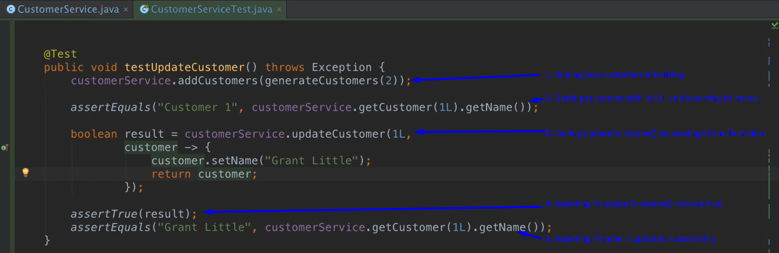  
   Test got passed.  
   